Core Bridging Communication



Dear Parents,

We are pleased to announce a new way to access resources for the Core Bridging Communication Program (CBC) that will give you an opportunity to practice with your child at home. The resources will be updated each month with new vocabulary. Below are directions. We welcome suggestions and feedback that will help this tool be a valuable resource for you at home.

First access the website <https://www.rcsdk12.org/28> locate and click on the Library.

Once you locate the library on the top navigation menu page, then maneuver mouse over the word to see second option for ASD.

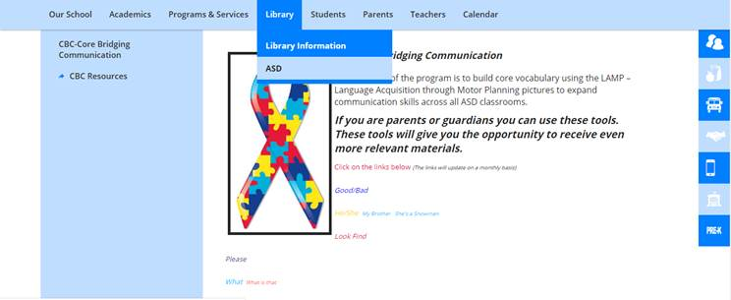

Click on ASD. Once you click on ASD you are now in the overview page for the CBC-Core Bridging Communication program**.**

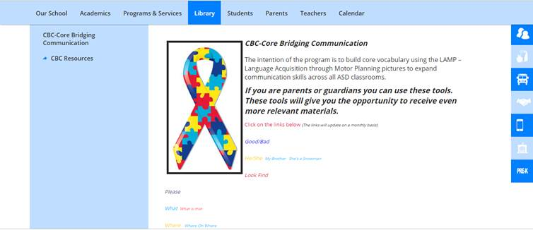

Notice on the far left the is a link for the CBC Resources

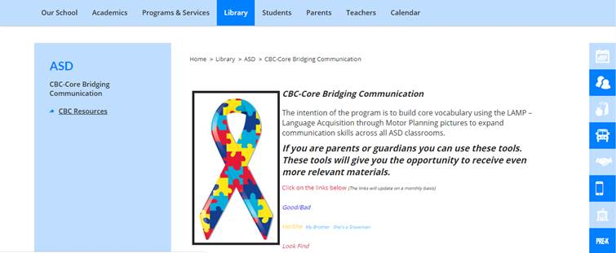

Inside of the CBC Resource link you’ll find all the folders for which you’ve allowed access. You can also click on the colorful links

Which will bring you to the same file.

